Statistics 140 Winter 17

Hand-In Assignment #4

Sarah Ruckman

Last 4 Digits of SID: 7194

1. Job recruiters Linda and Brandon have decided to assign three tasks to job applicants. Applicants receive a score of 1 if they successfully complete a task and 0 if they do not successfully complete a task. For a new group of applicants, the tasks are assigned and the following data recorded:

|  |  |  |  |  |
| --- | --- | --- | --- | --- |
| Job Applicant | Task 1 | Task 2 | Task 3 | Ri Totals |
| JA 1 | 1 | 1 | 1 | 3 |
| JA 2 | 1 | 1 | 1 | 3 |
| JA 3 | 1 | 1 | 0 | 2 |
| JA 4 | 1 | 1 | 0 | 2 |
| JA 5 | 0 | 1 | 1 | 2 |
| JA 6 | 1 | 1 | 0 | 2 |
| JA 7 | 0 | 1 | 0 | 1 |
| JA 8 | 1 | 0 | 1 | 2 |
| Cj Totals | 6 | 7 | 4 | 17 |

Perform the appropriate test of hypothesis to determine whether the three tasks are equally completed. Use α = 0.05.

**H0: The three tasks are equally completed**

**Ha: The three tasks are not equally completed**

Blocks: job applicants

N = 17

c = 3

r = 8

**TS = X2 with c-1 df = 3-1 = 2 df**

**= = 2.3333**

**RR = Reject H0 if T > X20.05,2= 5.992**

**Since T= 2.3333 is less than X20.05,2= 5.992, we do not reject H0**

**There is insufficient evidence to indicate at least one of the three tasks are not equally completed.**

1. Linda, Rachel and Luke have taken up dog-sled racing in hopes that someday they can enter The Iditarod Dog Sled Race in Alaska with Trusty Dusty, White Shadow and Lakota Dakota as their respective lead dogs. Since there is a lack of snow in Southern California, each have obtained a sled in which the runners have been replaced by wheels. After a significant number of practice runs, Linda, Rachel and Luke race every day (not necessarily together) for 3 months and record their time to finish the course (in minutes). Brandon does not believe there is a significant difference in median finish times between the three teams. To test his claim, Brandon takes three independent random samples of 10 times for each of the three teams, yielding the following data:

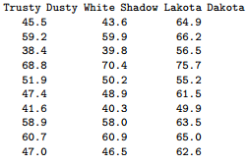

Using the median test, perform the appropriate test to determine whether at least one of the dogs yields a significantly different median finishing time. Use α = 0.05.

**H0: All the dogs have the same median finishing time**

**Ha: At least one dog has a significantly different median finishing time**

SAS Code:

options nocenter nodate nonumber ls = **78** ps =**55** formdlim = '#';

ods graohics off;

**data** dograces;

infile 'C:\Users\Sarah\Downloads\DOGRACE1S.DAT' firstobs =**2**;

do rows = **1** to **10**;

do dog_name = **1** to **3**;

if dog_name = **1** then level = 'Trusty Dusty ';

else if dog_name = **2** then level = 'White Shadow ';

else level = 'Lakota Dakota';

input times @@;

output;

end;

end;

**proc** **print**;

**proc** **sort**;

by level;

**proc** **print**;

**proc** **npar1way** median;

class level;

var times;

**run**;

**quit**;

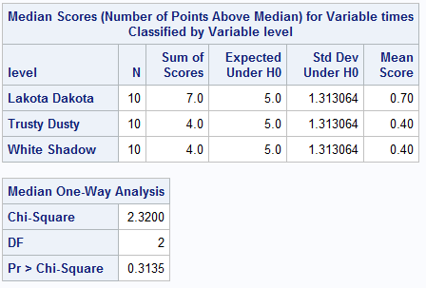

**TS = X2 = 2.300 with p-value = 0.3135**

**RR: Reject H0 if p-value < α = 0.05**

**Since p-value = 0.3135 is greater than α = 0.05, we do not reject H0**

**There is insufficient evidence to suggest a different median finishing time.**

1. A paintball enthusiast was interested in determining whether the type of camouflage uniform members wear makes a difference in the member being spotted by an opposing team member. Ten team members using plain camouflage uniforms and 10 using patterned camouflage uniforms were asked to stand (not move) in a wooded area and a team of observers was sent out to find them. The observers were asked to report the distance at which they first sight each paintball team member (true sightings) until all the paintball team members have been discovered. The distances (measured in meters) at which paintball team member is first detected are given in the table below.



Use the Mann-Whitney test to determine whether there is a difference in detection distance between patterned camouflage uniforms and plain camouflage uniforms. α=0.05.

**H0: There is no difference in detection distance between patterned camouflage and plain camouflage. (E(Plain) = E(Patterned))**

**Ha: There is a difference in detection distance between patterned camouflage and plain camouflage. (E(Plain) ≠ E(Patterned))**

R Code:

> plain <- c(25,28,16,34,38,21,29,43,32,36)

> plain

[1] 25 28 16 34 38 21 29 43 32 36

> patterned<- c(26,12,16,21,20,14,10,18,22,26)

> patterned

[1] 26 12 16 21 20 14 10 18 22 26

> wilcox.test(plain,patterned)

Wilcoxon rank sum test with continuity correction

data: plain and patterned

W = 88, p-value = 0.004541

alternative hypothesis: true location shift is not equal to 0

Warning message:

In wilcox.test.default(plain, patterned) :

cannot compute exact p-value with ties

**TS = p-value = 0.004541**

**RR = reject if p-value < α = 0.05**

**Since p-value = 0.004541 is less than α = 0.05, we reject H0**

**There is sufficient evidence to suggest there is a difference in detection distance between patterned camouflage and plain camouflage.**